
Project Report

Course and Classroom Management
(CCRM) System

Submitted to: Prepared by:
VITYARTHI PORTAL JATIN BHANDARI
VIT BHOPAL
24BCE10793
UNIVERSITY
November 24, 2025
A Java-based application for managing student academic records and course administration.

Contents
1 Introduction 2
2 Problem Statement 3
3 Functional Requirements 4
4 Non-functional Requirements 5
5 System Architecture 6
6 Design Diagrams 7
6.1 Use Case Diagram 7
6.2 Workflow Diagram 7
6.3 Sequence Diagram 7
6.4 Class/Component Diagram 7
6.5 ER Diagram (if storage used) 8
7 Design Decisions & Rationale 9
8.implementation detail 11
9 Testing Approach 12
10 Challenges Faced 13
11 Learnings & Key Takeaways 14
12 Future Enhancements 15
13 References 16

Chapter 1

Introduction
The Course and Classroom Management (CCRM) System is a comprehensive, commandline interface (CLI) application developed in Java. The primary objective of this project is to provide educational institutions with a robust and efficient tool for managing critical academic processes, including student enrollment, course catalog administration, and grade tracking.
The system leverages modern Java features (JDK 17+) and follows strict Object-Oriented Programming (OOP) principles and established design patterns to ensure high maintainability, reliability, and extensibility. Data persistence is managed using CSV files and the modern Java NIO.2 API for efficient file operations.
Chapter 2

Problem Statement
In many smaller educational settings, the management of student records, course capacities, and academic grades is often handled manually or through disparate, non-integrated systems (such as spreadsheets). This approach is highly susceptible to human error, lacks real-time data integrity checks, and makes reporting and data analysis cumbersome.
The need exists for a centralized, reliable, and automated system that can accurately manage student enrollment in real-time, enforce course prerequisites and capacity limits, and securely persist all academic records. The CCRM project addresses this need by providing a consolidated, OOP-driven solution.
Chapter 3

Functional Requirements
The CCRM system is required to perform the following core functionalities:
- Student Management: Ability to add, view, update, and delete student records (CRUD operations).
- Course Management: Ability to define and manage course details, including course code, title, capacity, and current enrollment count.
- Enrollment System: Allow administrators to enroll students in courses and track course capacity automatically.
- Grade Tracking: Allow instructors (or admins) to assign, update, and view grades for enrolled students.
- GPA Calculation: Automatically calculate the Grade Point Average (GPA) for each student based on their recorded grades.
- Data Persistence: The system must save all domain data (students, courses, enrollment records) to disk using CSV files.
- Data Validation: Implement comprehensive checks on all user inputs and business logic (e.g., preventing over-enrollment).
- Backup System: Provide automated backup capabilities for crucial data files.

Chapter 4

Non-functional Requirements
- Performance: All primary operations (CRUD, Enrollment) must execute within acceptable time limits, even with a moderate dataset size.
- Maintainability: The code base must adhere to solid OOP principles, be well-organized into logical packages, and be easily understood and modified by future developers.
- Security/Integrity: The system must prevent unauthorized changes to data files and ensure data consistency through robust exception handling and validation logic.
- Portability: Being developed in Java, the application must run successfully on any platform supporting a modern Java Runtime Environment (JRE).
- Usability: The Command-Line Interface (CLI) must provide clear, guided menu options and helpful error messages to the end-user.
Chapter 5

System Architecture
The CCRM system employs a three-tiered Service-Oriented Architecture (SOA) pattern, realized through a layered design structure:
- Presentation Layer (CLI): Handled by the edu.ccrm.cli package, this layer manages user interaction, displays output, and translates user input into service calls.
- Service/Business Logic Layer: Handled by the edu.ccrm.service package, this layer contains the core application logic, enforcing business rules (e.g., enrollment eligibility, capacity checks).
- Domain/Data Layer:
  - Domain: The edu.ccrm.domain package contains the core entities (Student, Course, Enrollment, etc.) using plain old Java objects (POJOs).
  - I/O & Persistence: The edu.ccrm.io package, utilizing Java NIO.2, is responsible for reading and writing data to CSV files, abstracting the storage mechanism from the service layer.

Chapter 6

Design Diagrams
The following diagrams illustrate the conceptual and structural design of the CCRM system.

6.1. Use Case Diagram
The Use Case Diagram maps the interactions between the primary actors (Administrator, Student, Instructor) and the core functions of the system.
This diagram shows the main interactions between users and the CCRM system.
Figure 6.1: Use Case Diagram for CCRM System

6.2. Workflow Diagram
The Workflow Diagram illustrates a key process in the system, such as student enrollment, from initiation to completion.
This flowchart details the step-by-step logic for course enrollment, including capacity checks.
Figure 6.2: Workflow Diagram for Student Enrollment Process

6.3. Sequence Diagram
This diagram shows the time-ordered sequence of interactions between the Command-Line Interface (CLI), Service Layer, and IO Layer when performing a critical action like adding a new student.
This diagram tracks the messages exchanged during the addition of a new student record.
Figure 6.3: Sequence Diagram for Adding a New Student Record

6.4. Class/Component Diagram
The Class Diagram shows the structure of the system’s classes, their attributes, methods, and the static relationships between them (Inheritance and Composition).
This diagram illustrates the static structure of domain and service classes.
Figure 6.4: Class Diagram for CCRM System

6.5. ER Diagram (if storage used)
Although the system uses CSV files, the data structure models relational concepts. The
Entity-Relationship (ER) Diagram shows the relationships between core entities like Student, Course, and the connecting Enrollment record.
This diagram shows the relationships between the persistent data entities (Student, Course, Enrollment).
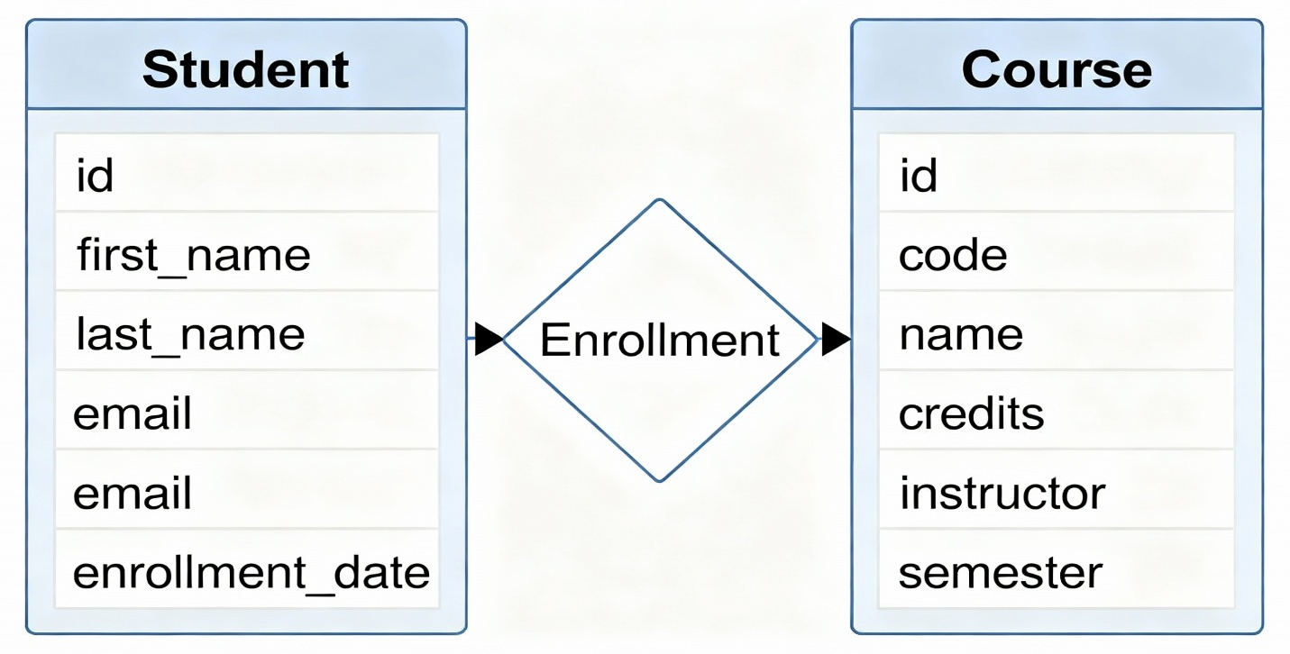
Figure 6.5: Entity Relationship Diagram for CCRM Data Structure
Chapter 7

Design Decisions & Rationale
DD.1 Technology Stack (Pure Java, CLI):
- Rationale: This decision was made to focus purely on core business logic and OOP principles, minimizing external dependencies and abstraction layers such as GUI frameworks or web servers, which often complicate initial development.
DD.2 Data Persistence (CSV Files):
- Rationale: For a small-to-medium project, CSV offers a simple, human-readable, and easily portable persistence mechanism. It allows the project to demonstrate file handling using modern Java NIO.2 without requiring complex setup for an external database.
DD.3 Use of Design Patterns (Singleton, Builder):
- Rationale: The Singleton Pattern is used for AppConfig to ensure a single, consistent instance of global settings across the application. The Builder Pattern (for complex entities like Course) simplifies object creation and improves readability by separating the construction from the representation.
DD.4 Inheritance and Interface Design:
- Rationale: Using inheritance (e.g., Person→Student/Instructor) and interfacebased design ensures code reusability and flexibility, making it easy to introduce new user types or data access methods in the future.

Chapter 8

Implementation Details
The implementation focuses on leveraging modern Java capabilities:
- Java Stream API: Used extensively in the Service Layer (edu.ccrm.service) for efficient, declarative data processing, such as filtering students, calculating GPAs, or finding courses that meet specific criteria.
- Java NIO.2: Employed in the edu.ccrm.io package for file operations, providing robust, non-blocking I/O capabilities for reading and writing CSV data and handling automated backups.
- Date/Time API (java.time): Used for all temporal operations (e.g., semester scheduling, student date of birth) to avoid the pitfalls of the legacy java.util.Date class.
- Custom Exception Handling: The system utilizes custom exceptions (edu.ccrm.exception) to manage specific application errors (e.g., CourseCapacityExceededException), providing clearer error messages to the CLI user.

Chapter 9

Testing Approach
A comprehensive testing strategy was employed to ensure the system’s correctness and reliability.
- Unit Testing (Assertions): Java’s built-in assert mechanism was utilized extensively within the domain and service layers to test pre-conditions and post-conditions of methods. This ensured that core business rules, such as data integrity checks and capacity limits, were enforced at the lowest level.
- Functional Testing: The application was tested manually through the CLI to verify that all functional requirements (CRUD, Enrollment, Grade Assignment) worked as expected from the user’s perspective.
- Integration Testing (I/O): The edu.ccrm.io classes were tested to ensure data was correctly serialized to and deserialized from CSV files without corruption, verifying the persistence mechanism.

Chapter 10

Challenges Faced
- Data Integrity in CSV: Maintaining relational integrity (e.g., ensuring an Enrollment record references a valid Student ID and Course ID) using simple CSV files proved challenging, necessitating careful validation logic in the IO layer upon loading data.
- Complex CLI User Experience: Designing a user-friendly and intuitive commandline experience, including robust input sanitization and error recovery, required significant iterative refinement.
- Generic Service Implementation: Abstracting the service layer to handle multiple domain entities while keeping the code DRY (Don’t Repeat Yourself) required careful use of Java Generics and interface definitions.
Chapter 11

Learnings & Key Takeaways
- Mastery of OOP: The project provided a practical application of core OOP principles, emphasizing the benefits of encapsulation, inheritance (Person → Student/Instructor), and polymorphism.
- Modern Java Features: Extensive experience was gained utilizing the Java Stream API for data manipulation and the NIO.2 for robust file system interaction, which are essential skills for modern Java development.
- Software Architecture: Understanding and implementing a layered architecture (Service Layer Pattern) proved critical for separating concerns, making the system easier to test and maintain.
- Importance of Assertions: The heavy reliance on Java’s assert mechanism reinforced the importance of writing defensive code that immediately validates assumptions and detects bugs early in the development lifecycle.

Chapter 12

Future Enhancements
- Database Migration: Replace the CSV persistence layer with a robust relational database (e.g., MySQL or PostgreSQL) using JDBC or JPA for improved scalability and transactional integrity.
- Graphical User Interface (GUI): Implement a GUI using JavaFX or Swing to enhance the user experience and accessibility beyond the command line.
- Web Service Exposure: Convert the service layer into a RESTful API using a framework like Spring Boot, allowing the system’s functionality to be accessed by web or mobile clients.
- Multi-User Access with Authentication: Implement proper user authentication and authorization (role-based access control) to secure the system for multiple simultaneous users (Admin, Instructor, Student).

Chapter 13

References
- Project Source Code: https://github.com/jatin170506/java-project
- Java 17 Documentation: Oracle Official Documentation.
- Object-Oriented Design Principles: Various online resources and academic materials on SOLID principles and Design Patterns.

